press ctrl+shift++ to add a column in excel

press ctrl+shift+down arrow to select the column

press ctrl+g to open goto window in excel

press ctrl+t to open the create table window

press ctrl+shift+downarrow

press ctrl+1 to bring upfront format cells dialog box

clean,trim, proper, upper, lower

press ctrl+h

Top Excel Tips and Tricks (Categoryran Wise)
- Basic Tips
- Formatting Tips
- Formula Tips
- Charting Tips
- Printing Tips
- Advanced Tips
- Data Cleansing Tips
- MOUSE Tricks
- One Time Set-Up Tips
- Time Saver Tips
Important: Don’t forget to download this e-book from here covering all of these tips and tricks in one PDF.

Basic Tips

1. Serial Numbers
If you work with large data then it’s better to add a serial number column to it. For me, the best way to do this is to apply the table (Control + 5) to the data and then add 1 in the above serial number, just like below.
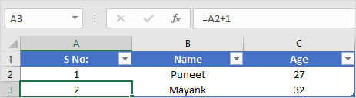
To do this, you simply need to add 1 to the first cell of the column and then create a formula to add 1 to the above cell’s value.
As you are using a table, whenever you create a new entry in the table, Excel will automatically drop down the formula and you’ll get the serial number.

2. Current Date and Time
The best way to insert the current date and time is to use the NOW function which takes date and time from the system and returns it.
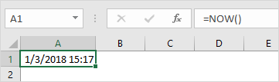
The only problem with this function is it’s volatile, and whenever you recalculate something it updates its value. And if you don’t want to do this, the best way is to convert it to hard value.
​You can also use the below VBA code.
Sub timeStamp()
Dim ts As Date
With Selection
.Value = Now
.NumberFormat = "m/d/yyyy h:mm:ss AM/PM"
End With
End Sub
Or these methods to insert a timestamp in a cell.

3. Select Non-Adjacent Cell ★
Normally we all do it this way, hold the control key and select cells one by one.
But I have found that there is a far better way for this. All you have do is, select the first cell and then press SHIFT + F8.
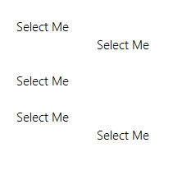
This gives you add or remove selection mode in which you can select cells just by selecting them.

4. Sort Buttons
If you deal with the data which needs to sort frequently then it’s better to add a button to the quick access toolbar (if it’s not there already).
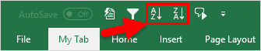
All you need to do is click on the down arrow on the quick access toolbar and then select “Sort Ascending” and “Sort Descending”. It adds both of the buttons to the QAT.

5. Drag and Drop
How to move data from one section of your worksheet to another? I’m sure you think about copy-paste but you can also use drag-drop for this.
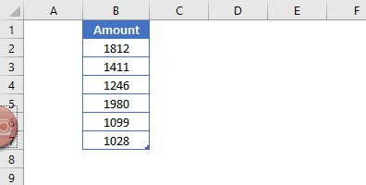
Simply select the range where you have data and then click on the border of the selection. By holding it move to the place where you need to put it.

6. Status Bar ★
The status bar is always there but we hardly use it to the full. If you right-click on it you can see there are a lot of options you can add.

7. Paste from Clipboard
There is a problem with normal copy-paste that you can only use a single value at a time.
But here is the kicker:
When you copy a value it goes to the clipboard and if you open the clipboard you can paste all the values which you have copied.
To open a clipboard click on the go to Home Tab ➜ Editing and then click on the down arrow.
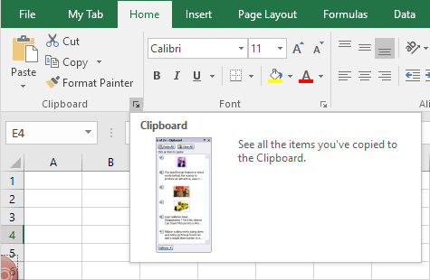
It will open the clipboard on the left side and you can paste values from there.
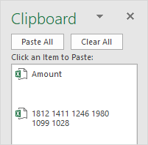

8. Add Bullet Points
The easiest way to insert bullet point in Excel is by using custom formatting and here are the steps for this:
- Press Ctrl + 1 and you will get the “Format Cell” dialogue box.
- Under the number tab, select custom.
- In the input bar, enter the following formatting.
● General;● General;● General;● General
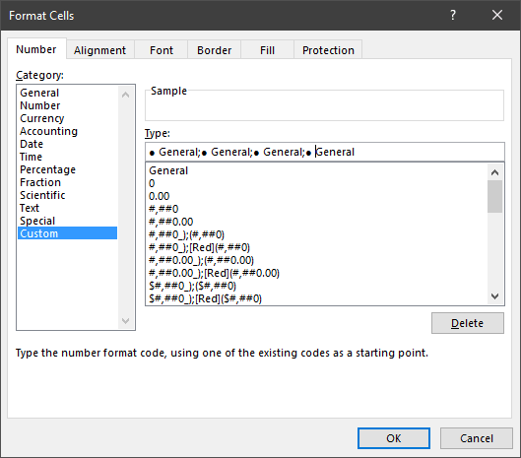
- Click OK.
Now, whenever you enter a value in the cell Excel will add a bullet before that.
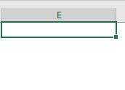

9. Copy of Worksheet
To create a copy of a worksheet in the same workbook drag and drop in the best way.


10. Undo-Redo Buttons
Just like sort buttons you can also add undo and redo buttons to the QAT. The best part about those buttons is you can use them to undo up to a particular activity without pressing the shortcut key again and again.
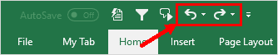

Formatting Tips

1. Auto Format
If you deal with financial data then auto format can be one of your best tools. It simply applies the format to small as well as large data sets (especially when data is in tabular form).
- First of all, you need to add it to the quick access toolbar (here are the steps).
- After that, whenever you need to apply the format, just select the data where you want to apply it and click on the AUTO FORMAT button from quick access toolbar.
- It will show you a window to select the formatting type and after selecting that click OK.
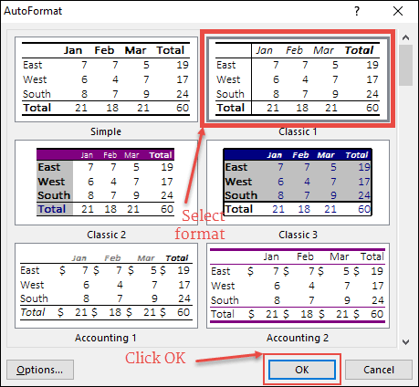
The AUTOFORMAT is a combination of six different formattings and you have the option to disable any of them while applying it.

2. Format Painter
The simple idea with the format painter is to copy and paste formatting from one section to another.
Let’s say you have specific formatting (Font, Cell Color, Bold, Border, etc.) in the range B2:D7, and with format painter, you can copy that formatting to range B9: D14 with a click.
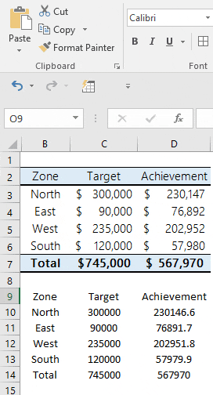
- First of all, select the range B2:D7.
- After that, go to the Home Tab ➜ Clipboard and then click on “Format Painter”.
- Now, select the cell C1 and it will automatically apply the formatting on B9: D14 .
The format painter is fast and makes it easy to apply to format from one section to another. Even you can also apply formatting multiple times, you can read more about it from here.

3. Cell Message
Let’s say you need to add a specific message to a cell, like “Don’t delete the value ”, “enter your name” or something like that.
In this case, you can add a cell message for that particular cell. When the user will select that cell it will show the message you have specified.
Here are the steps to do this:
- First of all, select the cell for which you want to add a message.
- After that, go to the Data Tab ➜ Data Tools ➜ Data Validation ➜ Data Validation.
- In the data validation window, go to the Input Message tab.
- Enter title, message and make sure to tick mark “Show input message when the cell is selected”.
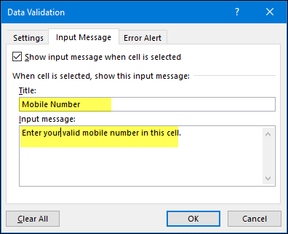
- In the end, click OK.
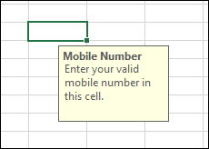
Once the message is showed you can drag and drop it to change its position.

4. Strikethrough
Unlike Word, in Excel, there is no option on the ribbon to apply strikethrough.
But I have figured out that there are 5 ways to do it and easiest from all of them is a keyboard shortcut.
All you need to do it select the cell where you want to apply the strikethrough and use the below keyboard shortcut.
Control + 5
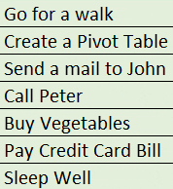
And if you are using MAC then:
⌘ + ⇧ + X
Quick Note: You can use the same shortcut keys if you need to do this for partial text.

5. Barcode
It’s one of those secret tips which most of the Excel users are unaware.
To create a bar-code in Excel all you need to do it install this bar-code font from ID-AUTOMATIC.

Once you install this font, you will have to type the number in a cell for which you want to create a bar-code and then apply the font style.
learn more about this tip from here

6. Month Name
Alright, let’s say you have a date in a cell and you want that date to show as a month or a year. For this, you can apply custom formatting.
- First of all, select the cell with a date and open formatting options (use Ctrl + 1).
- Select the “Custom” option and add “MMM” or “MMMMMM” for the month or “YYYY” for the year format.
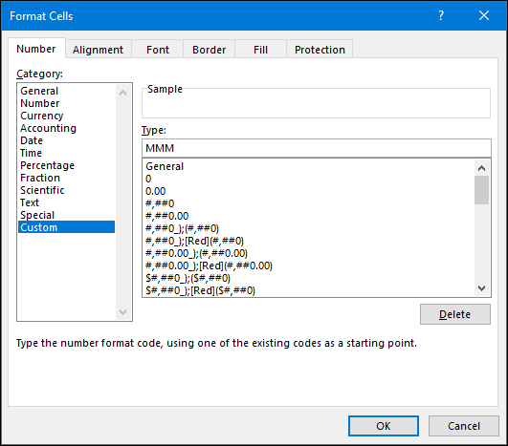
- In the end, click OK.
Custom formatting just changes the formatting of the cell from date to year/month but the value remains the same.

7. Highlight Blank Cells
When you work with large data sheets it’s hard to identify the blank cells from it. So the best way is to highlight them by applying a cell color.
- First of all, select all the data from the worksheet using the shortcut key Ctrl + A.
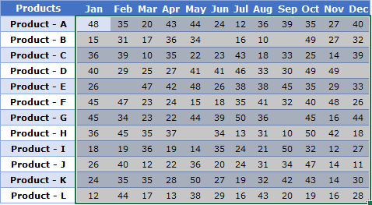
- After that, go to Home Tab ➜ Editing ➜ Find & Select ➜ Go To Special.
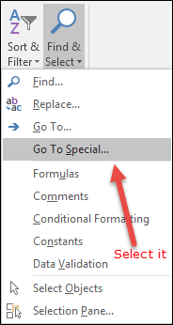
- From Go To Special dialog box, select Blank and click OK.
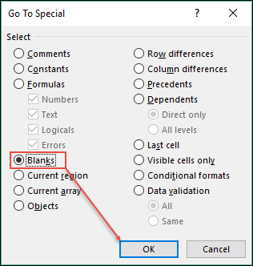
- At this point, you have all the blank cell selected and now apply a cell color using font settings.
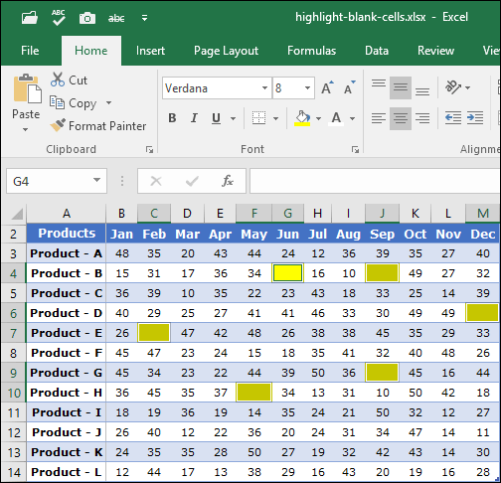
…but you can also use conditional formatting for this

8. Font Color with Custom Formatting
In Excel, we can apply custom formatting and in custom formatting, there is an option to use font colours (limited but useful).
For example, if you want to use the Green colour for positive numbers and red colour for negative numbers then you need to use the custom format.
[Green]#,###;[Red]-#,###;0;
To apply this all you need to do is:
- First of all, select the cells where you want to apply this format.
- After that open format option using keyboard shortcut Ctrl + 1 and go to the “Custom” category and the custom format in the input dialogue box.
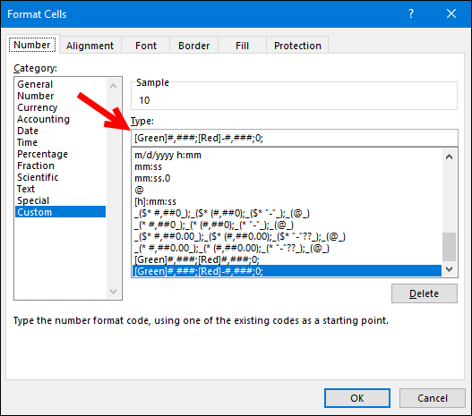
- In the end, click OK.

9. Theme Color
We all have some favourite fonts and colours which we use in Excel. Let’s say you received a file from your colleague and now you want to change the font and colours for the worksheet from that file. The point is, you need to do this one by one for each worksheet and that takes time.
But if you create a custom theme with your favourite colours and fonts then you can change the style of the worksheet with a single click. For this, all you have to do is apply your favourite designs to the tables, colours to the shapes and charts, font style and then save it as a custom theme.
Steps:
- Go to the Page Layout Tab ➜ Themes ➜ Save Current Theme. It opens a “Save As” dialogue box, name your theme and save it.
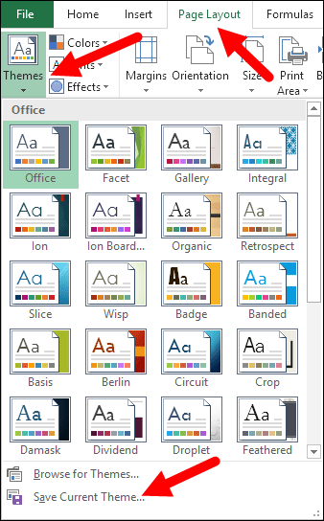
- And now, every time you need just one click to change any worksheet style to your custom style.

10. Clear Formatting
This is a simple keyboard shortcut that you can use to clear formatting from a cell or range of cells.
Alt ➜ H ➜ E ➜ F
Or, otherwise, you can also use clear formatting option from the Home Tab (Home Tab ➜ Editing ➜ Clear Clear ➜ Formats).
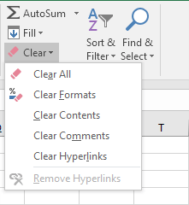

Formula Tips

1. Sentence Case
In Excel, we have three different functions (LOWER, UPPER, and PROPER) to convert a text into different cases.
But there is no option to convert a text into sentences case. Here is the formula which you can use:
=UPPER(LEFT(A1,1))&LOWER(RIGHT(A1,LEN(A1)-1))
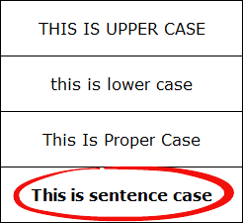
This formula converts the first letter of a sentence into capital and rest of all in small…
…learn how this formula works

2. Random Numbers
In Excel, there are two specific functions which you can use to generate random numbers. First is RAND which generates random numbers between 0 and 1.
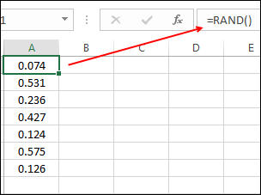
And second is RANDBETWEEN which generates the random numbers within the range of two specific numbers.
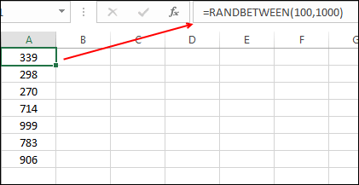
ALERT: These both functions are volatile so whenever you re-calculate your worksheet or hit enter they update their values so make sure to use them with caution.
You can also use RANDBETWEEN to generate random letters as well.

3. Count Words
In Excel, there is no specific function to count words.
You can count characters with LEN but not words. But, you can use the following formula which can help you to count words from a cell.
=LEN(A1)-LEN(SUBSTITUTE(A1,” “,””))+1
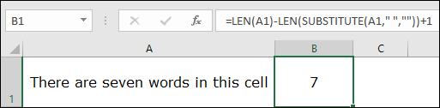
This formula counts the number of spaces from a cell and adds 1 to it after that which equals the total number of words in a cell.

4. Calculate Age
The best way to calculate a person’s age is by using the DATEDIF function. This mysterious function is specifically made to get the difference between two dates.

And the formula will be:
=”Your age is “& DATEDIF(Date-of-Birth,Today(),”y”) &” Year(s), “& DATEDIF(Date-of-Birth,TODAY(),”ym”)& ” MONTH(s) & “& DATEDIF(Date-of-Birth,TODAY(),”md”)& ” Day(s).”

5. Ratio
I have figured out that there are 4 different ways to calculate ratio in Excel but using a simple divide method is the easiest one.
All you need to do is divide the larger number into the smaller one concatenate it with a colon and one and here’s the formula you need to use:
=Larger-Number/Smaller-Number&”:”&”1″
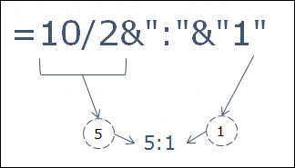
This formula divides the larger number with the smaller so that you can take the smaller number as a base (1).

6. Root of Number
To calculate square root , cube root or any root of a number the best way is to use exponent formula. In exponent formula, you can specify the Nth number for which you want to calculate the root.
=number^(1/n)
For example, if you want to calculate a square root of 625 then the formula will be:
=625^(1/2)
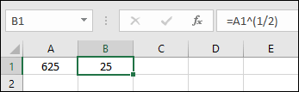

7. Days in Month
To get a total number of days in a month dynamically you can use the following formula:
=DAY(EOMONTH(TODAY(),0))
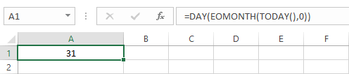

8. Month’s last Date
To simply get the last date of a month you can use the following dynamic formula.
=DATE(YEAR(TODAY()),MONTH(TODAY())+1,0)
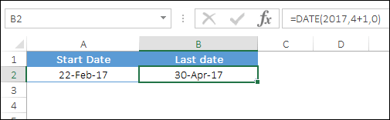

9. INDEX MATCH
As we all know there is no way to look up to left for a value using VLOOKUP. But if you switch to INDEX MATCH you can look up in any direction.

10. SUMPRODUCT IF
You can use the below formula to create a conditional SUMPRODUCT and product values using a condition.
=SUMPRODUCT(–(C7:C19=C2),E7:E19,F7:F19)

Charting Tips

1. Smooth Line
If you love to use a line chart then you are awesome but it would be more awesome if you use a smooth line in the chart.
This will give a smart look to your chart.
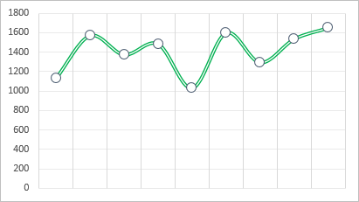
Here are the steps:
- Select the data line in your chart and right click on it.
- Select “Format Data Series”.
- Go to Fill & Line ➜ Line ➜ Tick mark “Smoothed Line”.

2. Chart Formatting
Copy Chart Format in Excel

3. Hide Axis Labels
This charting tip is simple but still quite useful. If you don’t want to show axis label values in your chart you can delete them.
But the better way is to hide them instead of deleting. Here are the steps:
- Select Horizontal/Vertical axis in the chart.
- Go to “Format Axis” Labels.
- In label position, select “None”.
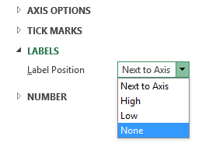
And again if you want to show it then just select “Next to axis”.

4. Display Units
If you are dealing with the large numbers in your chart, you can change the units for axis values.

Here are the steps:
- Select chart axis your chart and open format “Format Axis” options.
- In axis options, go to “Display Units” where you can select unit for your axis values.

5. Round Corner
I often use Excel charts with rounded corners and if you like to use round corners too, here are the simple steps.
- Select your chart and open formatting options.
- Go to Fill and Line ➜ Borders.
- In borders sections, tick mark rounded corners.


6. Hide Gap
Let’s say if you have a chart with monthly sales in which Jun has no amount and cell is empty. You can use the following options for that empty cell.
- Show the gap for the empty cell.
- Use zero.
- Connect data points with the line.
Here are the steps to use these options.
- Right, click on your chart & select “Select Data”.
- In select data window, click on “Hidden and Empty Cell”.
- Select your desired option from “Show Empty Cell as”.
Make sure to use “Connect data points with the line” (recommended).

7. Pictograph in Excel
How to Create a Pictograph in Excel

8. Chart Template
Let’s say if you have a favorite chart formatting which you want to apply every time you create a new chart. You can create a chart template to use it anytime in the future and steps are as follow.
- Once you have done with your favorite formatting, right click on it & select “Save As Template”.
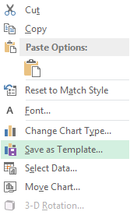
- Using save as dialog box, save it in the template folder.
- To insert a new with your favorite template, select it from templates in insert chart dialog.
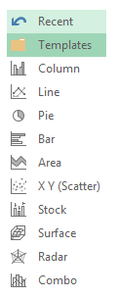

9. Default Chart
You can use a shortcut key to insert a chart, but the problem is, it will only insert the default chart, and in Excel, the default chart type is “Column Chart”.
So if your favorite chart is a line chart, then the shortcut is useless for you. But let’s conquer this problem. Here are the steps to fix this:
- Go to Insert Tab ➜ Charts.
- Click on the arrow at the bottom right corner.
- Then in your insert chart window, go to “All Charts” and then select the chart category.
- Right, click on the chart style which you want to make your default Select “Set As Default Chart”.
- Click OK.


10. Hidden Cells
When you hide a cell from the data range of a chart, it will also hide that data point from the chart as well. To fix this, just follow these steps.
- Select your chart and right click on it.
- Go to ➜ Select Data ➜ Hidden and empty cells.
- From the pop-up window, tick mark “Show data in hidden rows and columns”.
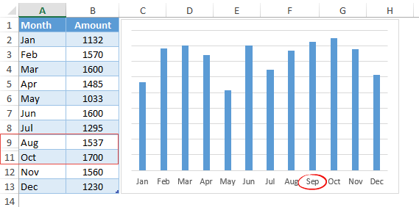

Printing Tips

1. Print Titles
Let’s say you have headings in your table and you want to print those headings on every page you print. In this case, you can fix “Print Titles” to print those headings on each page.
- Go to “Page Layout Tab” ➜ Page Set Up ➜ Click on Print Titles.
- Now in the page setup window go to sheet tab and specify following things.
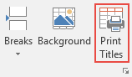
- Print Area: Select the entire data which you want to print.
- Rows to repeat at the top: Heading row(s) which you want to repeat on every page.
- Columns to repeat at the left: Column(s) which you want to repeat at the left side of every page (if any).
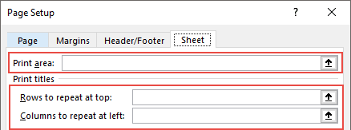

2. Page Order
Specifying the page order is quite useful when you want to print large data.
- Go to File Tab ➜ Print ➜ Print Setup ➜ Sheets Tab.
- Now here, you have two options:
  - The First Option: To print your pages using a vertical order.
  - The Second Option: To print your pages using a horizontal order.
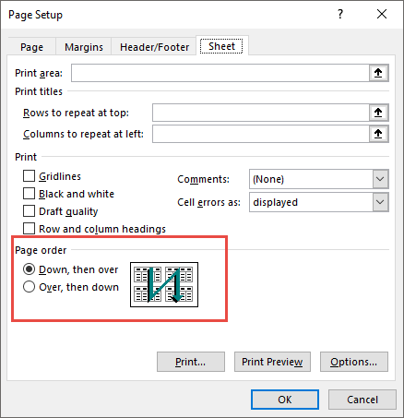

3. Print Comments
If you use comments in your reports then you can print them as well. At the end of the all printed pages, you can get a list of all the comments.
- Go to File Tab ➜ Print ➜ Print Setup ➜ Sheets Tab.
- In the print section, select “At the end of the sheet” using comment dropdown.
- Click OK.

4. Scale to Fit
Sometimes we struggle to print entire data on a single page. In this situation, you can use the “Scale to Fit” option to adjust the entire data into a single page.
- Go to File Tab ➜ Print ➜ Print Setup ➜ Page Tab.
- Next, you need to adjust two options:
  - Adjust % of normal size.
  - Specify the number of pages in which you want to adjust your entire data using width and length.
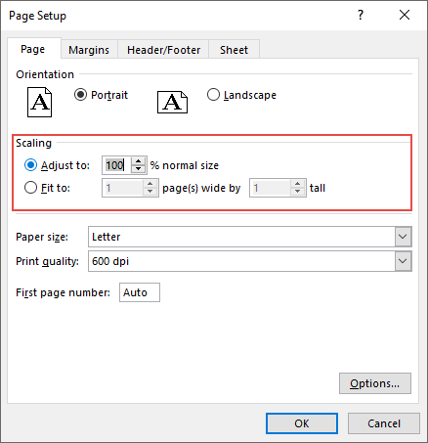

5. Custom Header-Footer
Instead of using the page number in the header and footer, you can also use a custom header and footer.
- Go to File Tab ➜ Print ➜ Print Setup ➜ Header/Footer.
- Click on custom header or footer button.
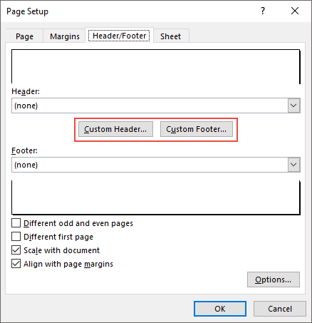
- Here you can select alignment of the header/footer.
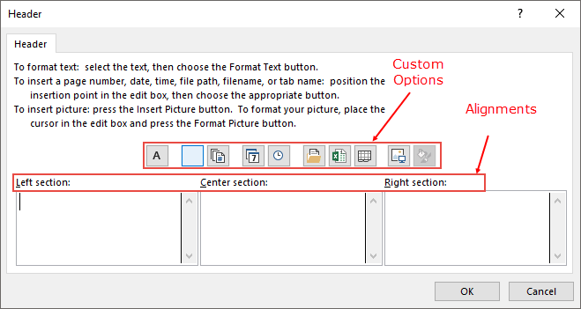
- And the following options can be used:
  - Page Number
  - Page Number with total pages.
  - Date
  - Time
  - File Path
  - File Name
  - Sheet Name
  - Image

6. Center on Page
Imagine you have fewer data to print on a page. In this case, you can align it at the center of the page while printing.
- Go to File Tab ➜ Print ➜ Print Setup ➜ Margins.
- In “Center on Page” you have two options to select.
  - Horizontally: Aligns data to the center of the page.
  - Vertically: Aligns data to the middle of the page.
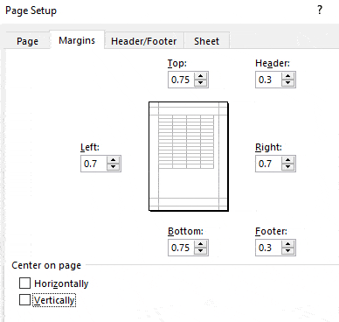

7. Print Area
The simple way to print a range is to select that range and use the option “print selection”.
But what if you need to print that range frequently, in that case you can specify the printing area and print it without selecting it every time.
Simply go to the

8. Custom Margin
- Go to File Tab ➜ Print.
- Once you click on print, you’ll get an instant print preview.
- Now from the bottom right side of the window, click on “Show Margins” button.
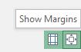
It will show all the margins applied and you can change them just by drag and drop.

9. Error Values
You can replace all the error values while printing with a specific value (three other values to use as a replacement).
Here are the steps:
- Go to File Tab ➜ Print ➜ Print Setup ➜ Sheet.
- Select replacement value from “Cell error as” drop down.
- You have three options to use as a replacement.
  - Blank
  - Double minus sign.
  - “#N/A” error for all the errors.
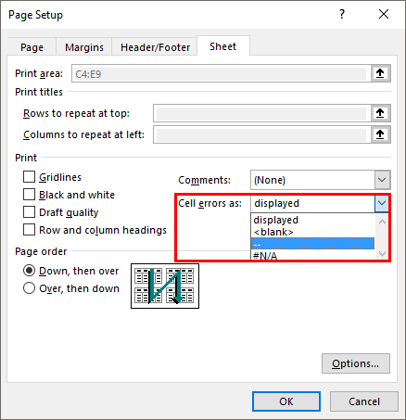
- After selecting the replacement value, click OK.
I believe using “Double minus sign” is the best way to present errors in a report while printing it on a page.

10. Custom Start Page Number
If you want to start page number from a custom number let’s say 5. You can specify that number and rest of the pages will follow that sequence.
- Go to File Tab ➜ Print ➜ Print Setup ➜ Page.
- In the input box “First page Number”, enter the number from where you want to start the page number.
- In the end, click OK.
Important Note: This option will only work if you have applied header/footer in your worksheet.

Advanced Tips

1. Tracking Important Cells
Sometimes we need to track some important cells in a workbook and for this, the best way is to use the watch window.
In the watch window, you add those important cells and then get some specific information about them in one place (without actually navigating to each cell).
Here are the steps to use it:
- First of all, go to Formula Tab ➜ Formula Auditing ➜ Watch Window.
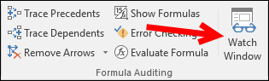
- Now in “Watch Window” dialog box, click on “Add Watch”.
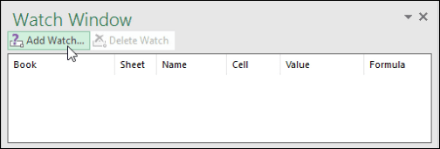
- After that select the cell or range of cells that you want to add and click OK.
Once you hit OK you’ll some specific information about the cell(s) in the watch window.

2. Flash Fill
Flash fill is one of my favorite options to use in Excel. It’s like a copycat, perform the task which you have performed.
Let me give you an example.
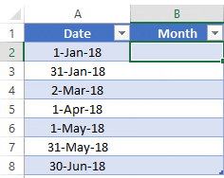
Here are the steps to use it:
You have dates in the range A1: A10 and now, you want to get the month from the dates in the B column.
All you need to do is to type the month of the first date in the cell B1 and then come down to cell B2 and press the shortcut key CTRL + E.
Once you do this it will extract the month from the rest of the dates, just like below.

3. Combine Worksheets
I’m sure somewhere in the past you have received a file from your colleague where you have 12 different worksheets for 12 months data.
In this case, the best solution is to combine all of those worksheets using the “Consolidate” option and here are the steps for this.
- First of all, add a new worksheet and then go to Data Tab ➜ Data Tools ➜ Consolidate.
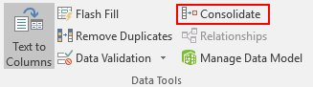
- Now in the “Consolidate” window, click on the upper arrow to add the range from the first worksheet and then click on the “Add” button.
- Next, you need to add references from all the worksheets using the above step.
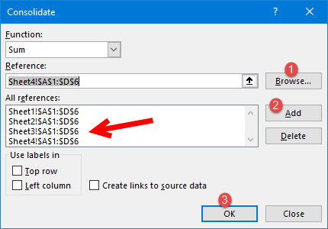
- In the end, click OK.

4. Protect a Workbook
Adding a password to a workbook is quite simple, here are the steps.
- While saving a file when you open a “Save As ” dialog box go to Tools General Options.
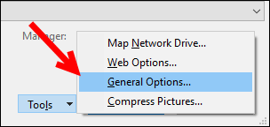
- Add a password to for “Password to Open” and click OK.
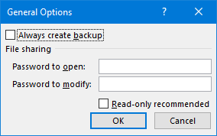
- Re-enter the password and click OK again.
- In the end, save the file.
Now, whenever you re-open this file it will ask you to enter the password to open it.

5. Live Image
In Excel, using a live image of a table can help you resize it according to space and to create a live image there are two different ways which you can use.
One is camera tools and the second is the paste special option. Here the steps to use camera tool and for paste special use the below steps.
- Select the rage you want to paste as an image and copy it.
- Go to the cell and right click, where you want to paste it.
- Go to Paste Special ➜ Other Paste ➜ Options Linked Picture.
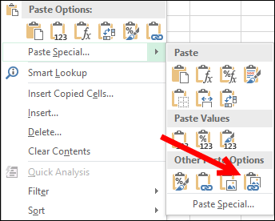
Make sure to read this guide about camera tool to learn more about linked images.

6. Userform
A few of the Excel users know that there is a default data entry form is there which we can use. And the best part is there is no need to write a single line of code for this.
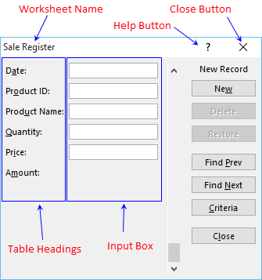
Here’s how to use it:
- First of all, make sure you have a table with headings where you want to enter the data.
- After that select any of the cell from that table and use the shortcut key Alt + D + O + O to open the user form.

7. Custom Tab
We all some favorite option or some options which we use frequently. To access all those options in one place you create tab and add them to it.
Follow these steps:
- First of all, go to File Tab ➜ Options ➜ Customize Ribbon.
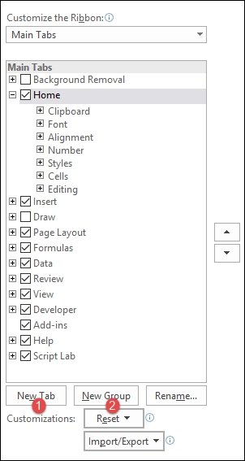
- Now click on “New Tab” (this will add a new tab).
- After that right click on it and name it and then name the group.
- Finally, we need to add options to the tab and for this go to “Choose Commands From” and add them to the tab one by one.
- In the end, click OK.
Now you are a new tab in the Excel ribbon with all the favorite options.

8. Goal Seek
In simple words, Goal Seek is a problem-solving tool. It helps you find the input value by proving the value you want in the result.
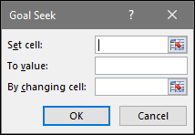
…here is the complete guide to learn about it.

9. Text to Speech
This is an option where you can make Excel speak the text you have entered into a cell or a range of cells.
click here read full about this option…

10. Named Range
To create a named the range the easiest method is to select the range create it using the “Create from Selection” option.
Here are the steps to do this:
- Select the column/row for which you want to create a named range.
- Right click and click on “Define name…”.
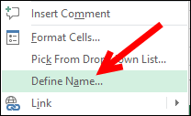
- Select the option to add the name for the named range and click OK.
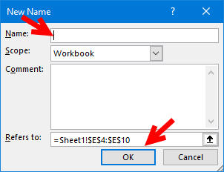
That’s it.

Data Cleansing Tips

1. Trim
TRIM can help you to remove extra spaces from a text string. Just refer to the cell from where you want to remove the spaces and it will return the trimmed value in the result.
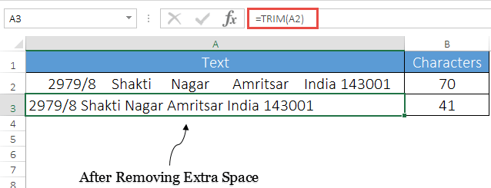

3. Remove Duplicates
One of the most common thing which we face while working with large data is “Duplicate Values”. In Excel, to remove these duplicate values is quite simple.
Here’s how to do this.
- First of all, select any of the cells from the data or select the entire data.
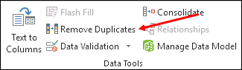
- After that, go to Data ➜ Data Tools ➜ Remove Duplicates.
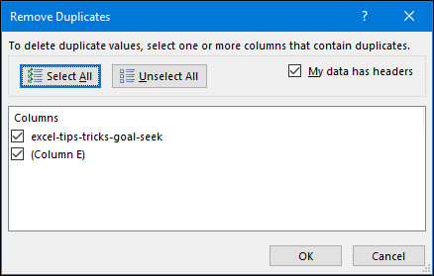
- At this point, you have “Remove Duplicates” window and from this window, select/de-select the columns which you want to consider/not consider while removing duplicate values.
- In the end, click OK.
Once you click OK, Excel will remove all the rows from the selected data where values are duplicate and show a message with the number of values removed and unique values left.

4. Combine Text (Fill Justify)
I know five different ways to merge text from a range but out of those Fill Justify is my favorite.
It’s one of the less used options in Excel, but worth not to be missed for any reason. Let say you have words in the range A1: A5 and you want to concatenate all of them in a single cell.
Here’s how to do this with fill justify.
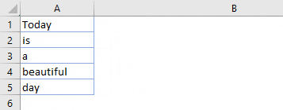
- First of all, make column A enough wide so that the entire text can be combined into one cell.
- After that, select the entire range.
- Now, go to Home Tab ➜ Editing ➜ Fill ➜ Justify.
Boom! it combined the text from range A1:A5 to cell A1.

5. Remove Specific Character
Let’s say you have some text values in a column and from those values you want to replace a specific character or a word…
…you can do this simply by find and replace option.
Let say you have words in the range A1: A5 and you want to concatenate all of them in a single cell.
Here’s how to do this with fill justify.
- All you need to do is select that column and open the find and replace dialog box.
- After that click on the “Replace” tab.
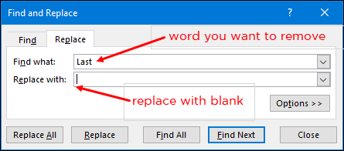
- Now here, in “Find What” enter the character you want to replace and make sure to leave “Replace with” blank.
- Now click on “Replace All”.
The moment you click on “Replace All” Excel will remove that particular character from the entire column.
Let’s say you have some text values in a column and from those values you want to replace a specific character or a word…
…you can do this simply by find and replace option.
Let say you have words in the range A1: A5 and you want to concatenate all of them in a single cell.
Here’s how to do this with fill justify.
- All you need to do is select that column and open the find and replace dialog box.
- After that click on the “Replace” tab.
- Now here, in “Find What” enter the character you want to replace and make sure to leave “Replace with” blank.
- Now click on “Replace All”.
The moment you click on “Replace All” Excel will remove that particular character from the entire column.

6. Combine Text
So you have text in multiple cells and you want to combine all the text into one cell. No, this time not with fill justify. We are doing it with TEXT JOIN.
If you use Office 365, there is new function TEXTJOIN which is a game changer when it comes to the concatenation of text.
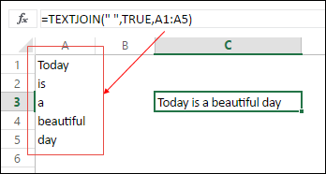
Here’s the syntax:
TEXTJOIN(delimiter, ignore_empty, text1, [text2], …)
All you need to do is to add a delimiter (if any), and TRUE if you want to ignore empty cells, and in the end, refer to the range.

7. Unpivot Data
Look at the below table you can use it as a report but can use you use it further as a raw data.
No, you can’t.
But if you convert this table in something like below you can you can use it easily anywhere.
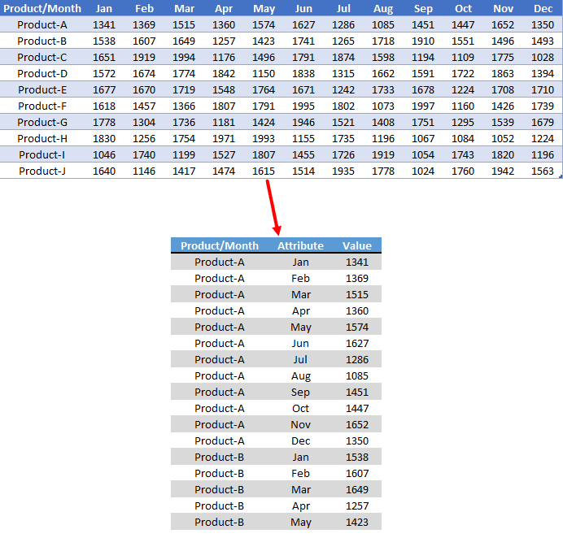
But if you convert this table in something like below you can you can use it easily anywhere.
So how to do this?
Power Query
…here’s the simple steps you need to follow.

8. Delete Error Cells
Mostly while working with large data it obvious to have error values but it’s not good to keep them.
The easiest way to deal with these error values is select them and delete them and these are the simple steps.
- First of all, go to Home Tab ➜ Editing ➜ Find & Replace ➜ Go To Special.
- In the Go To dialog box, select formula, and tick mark errors.
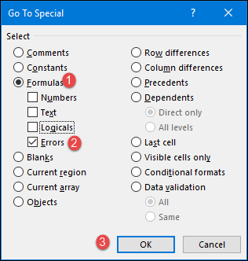
- In the end, click OK.
Once you click OK it will select all the errors and then you can simply delete all by using “Delete” button.

9. Arrange Columns
Let’s say you want to arrange columns from the data using a custom order.
The normal way is to cut and paste them one by one.
But we also have an out of the box way.
In Excel, you can sort columns just like you sort rows and by using the same methods you can arrange them in a custom order.
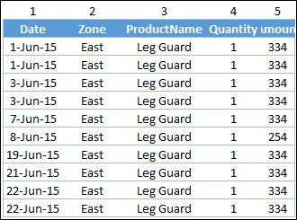
…click here to learn this full tip.

10. Convert to Date
Sometimes you have dates which are stored as text and you can use them in a calculation and further analysis. To simply convert them back to valid dates you can use DATEVALUE function…
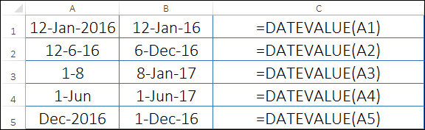
…and other ways to convert text to date.

Negative to Positive
The easiest way to convert a negative number into a positive is by using ABS function.
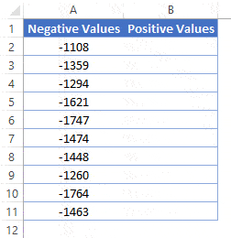

MOUSE Tricks

1. Format Painter
Before I started to use format painter for applying cell formatting, I was using paste special with the shortcut key. Here’s how to do this:
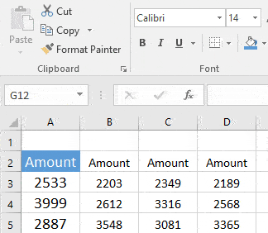
- Select the cell or a range from where you want to copy cell formatting.
- Go to ➜ the Home Tab ➜ Clipboard.
- Now, make a double click on the “Format Painter” button.
- As soon as you do this, your cursor will convert into a paintbrush.
- Now, you can apply that formatting anywhere in your worksheet, in another worksheet or, even in another workbook.

2. Rename a Worksheet
I always found it quicker than using a shortcut key to change the name of a worksheet. All you have to do is just double click on the sheet tab and enter a new name.

Let me tell you why this method is faster than using a shortcut. Suppose if want to rename more than one worksheet using shortcut key.
Before you change the name of a worksheet, you need to activate it. But if you use the mouse it will automatically activate that worksheet and edit the name with only two clicks.

3. Fill Handle
I am sure shortcut addicts always use a shortcut key to drag formulas and values in downward cells. But using a fill handle is more impressive than using a shortcut key.
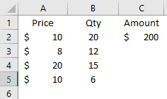
- Select the cell in which you have a formula or a value which you want to drag.
- Make a double click on the small square box at the right bottom of the cell selection border.
This method only works if you have values in corresponding column and it works only in the vertical direction.

4. Hide Ribbon
If you want to work in a distraction-free mode, you can do this by collapsing your Excel ribbon.
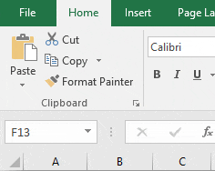
Just make a double click on the active tab in your ribbon and it will collapse the ribbon. And if you want to expand it back just double click on it again.

5. Edit a Shape
You often use shapes in our worksheets to present some messages and you have to insert some text into those shapes.
Besides the typical method, you can use double click to edit a shape and insert the text into it.

You can also use this method to edit and enter text in a checkbox or into a chart title.

6. Column Width
Whenever you have to adjust column width you can double click on the right edge of the column header.
It auto sets the column width according to the column data.
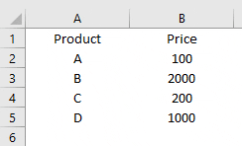
The same method can be used to auto adjust row width.

7. Go to the Last Cell
This trick can be useful if you are working with a large dataset. By using a double click, you can go to the last cell in the range which has data.
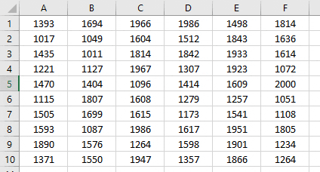
You have to click on the right edge of the active cell to go to the right side & on the left edge if you want to go to the right side.

8. Chart Formatting
If you use Control + 1 to open formatting options to format a chart, then I bet you’ll love this trick. All you have to do is just make a double-click on the border of the graph to open formatting option.
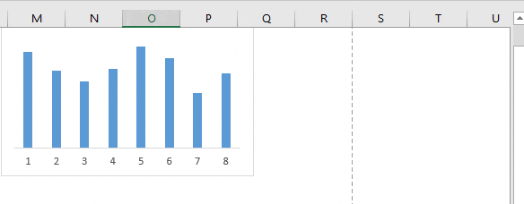

9. Pivot Table Double Click
Let’s say someone sent you a pivot table without the source data. As you already know Excel stores data in pivot cache before creating a pivot table.
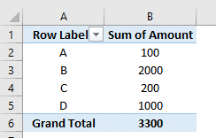
You can extract data from a pivot table by double-clicking on data values. As soon as you do this Excel will insert a new worksheet with the data which has used in the pivot table.

10. Right Click Menu
There is a right-click drop-down menu in Excel which few users know about. To use this menu all you need to do is select a cell or a range of the cell and then right-click and while holding it, drop the selection to somewhere else.
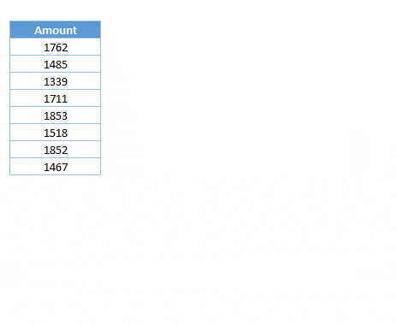

One Time Set-Up Tips

1. Default File Saving Location
Normally while working on Excel I create more than 15 Excel files every day.
And, if I save each of these files to my desktop it looks nasty.
To solve this problem, I have changed my default folder for saving a workbook and here’s you can do this.
- First of all, go to the file tab and open Excel options.

- In Excel options, go to “Save” category.
- Now, there is an input bar where you can change the default local file location.
- From this input bar, change the location address and in the end, click OK.
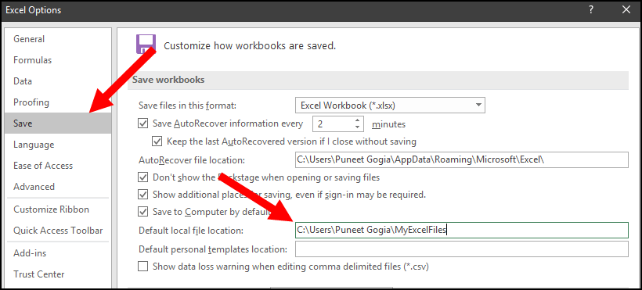
From now onward, when you open “Save As” dialog box Excel will show you the location you have specified.

2. Disable Start Screen
I’m sure just like me you hate when you open Microsoft Excel (or any other Office app) and you see the start pop-up screen. It takes time depending on your system’s speed and add-ins you have installed. Here are the steps to disable the start-up screen in Microsoft Office.
- First of all, go to the file tab and open Excel options.
- In Excel options, go to the “General” category.
- From option, drill down to “Start-Up” options and un-tick the “Show the Start screen when this application starts”.
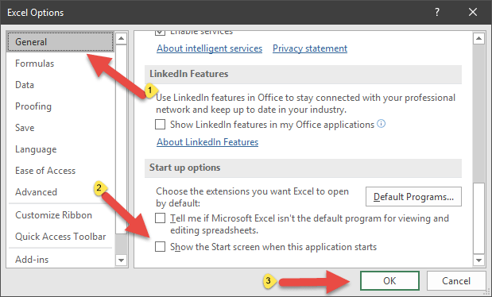
- In the end, click OK.
From now onward, every time when you start Excel it will directly open the workbook without showing the start-up screen.

3. Developer Tab
Before you start writing VBA codes the first thing you need to do is to enable “Developer Tab”. When you first install Microsoft Excel, developer wouldn’t be there. So you need to enable it from settings.
- First of all, go to File tab and click on “Customize Ribbon” category.
- Now from the tab list, tick marks the developer tab and click OK.
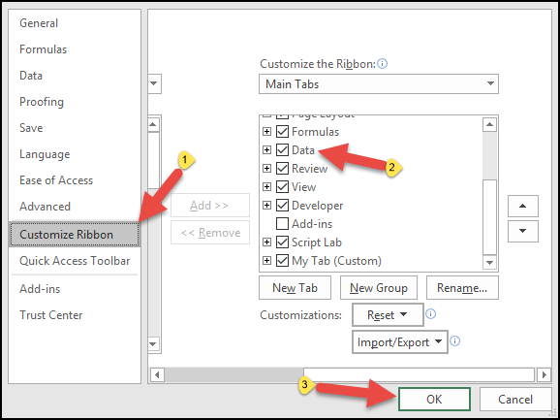
Now when you come back to your Excel window you’ll have developer tab on the ribbon.

4. Enable Macros
When you open a macro-enabled file you need to enable macro options to run VBA codes. Follow these simple steps:
- First of all, go to the File tab and click on the “Trust Center” category.
- From here click on “Trust Center Settings”.
- Now in “Trust Center Settings”, click on macro settings.
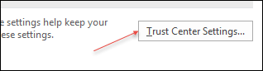
- After that, click on “Enable all macros with Notifications”.
- In the end, click OK.

5. AutoCorrect Option
If you do a lot of data entry in Excel then this option can be a game changer for you.
With the auto correct option, you can tell Excel to change a text string into another when you type it.
Let me tell you an example:
My name is “Puneet” but sometimes people write it like “Punit” but the correct spelling is the first one. So what I can do is, use auto correct and tell Excel to change “Punit” into “Puneet”.
Follow these simple steps:
- First of all, go to the File tab and go to options and click on “Proofing” category.
- After that, click on “AutoCorrect Option” and this will open the auto-correct window.
- Here in this window, you have two input bars to specify the text to replace and text to replace with.
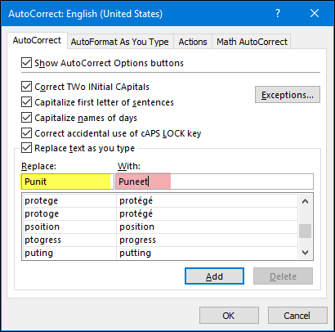
- Enter both of the values and then click OK.

6. Custom List
Just think like this, you have a list of 10 products which you sell. Whenever you need to insert those product name you can insert them using a custom list.
Let me tell you how to do this:
- First of all, go to File tab and go to options and click on “Advanced” category.
- Now, drill down and go to “General” section and click on “Edit Custom List…”.
- Now in this window, you can enter the list or you can also import it from a range of cells.
In the end, click OK.
Now, to enter the custom list you have just created, enter the first entry of the list in cell and then drill down that cell using fill handle.

7. Apply Table
If you use pivot tables a lot then it’s important to apply the table to the raw data.
With a table, there is no need to update the pivot table’s data source and it drag-down formulas automatically when you add a new entry.
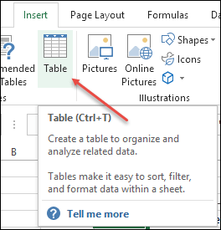
To apply table to the data just use Ctrl + T keyboard shortcut key and click OK.

8. Gridline Color
If you are not happy with the default color of cell grid-lines then you can simply change it with a few clicks and follow these simple steps for this:
- First of all, go to File tab and click on “Advanced” category.
- Now, go to “Display options for this workbook” section and select the color you want to apply.
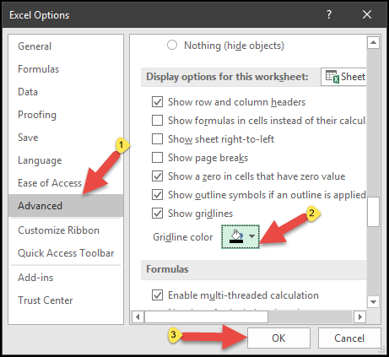
- In the end, click OK.

9. Pin to Taskbar
This is one of my favorite one-time set up to save time in the long run. The thing is instead of going to start menu to open Microsoft Excel, the best way is to pint it to the task-bar.
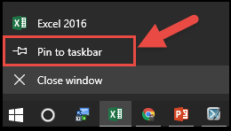
This way you can open it by clicking on the icon from the taskbar.

10. Macro to QAT
If you have a macro code which you need to use frequently. Well, the easiest way to run a macro code is to add it to the quick access toolbar.
- First of all, go to File tab and click on “Quick Access Toolbar” category.
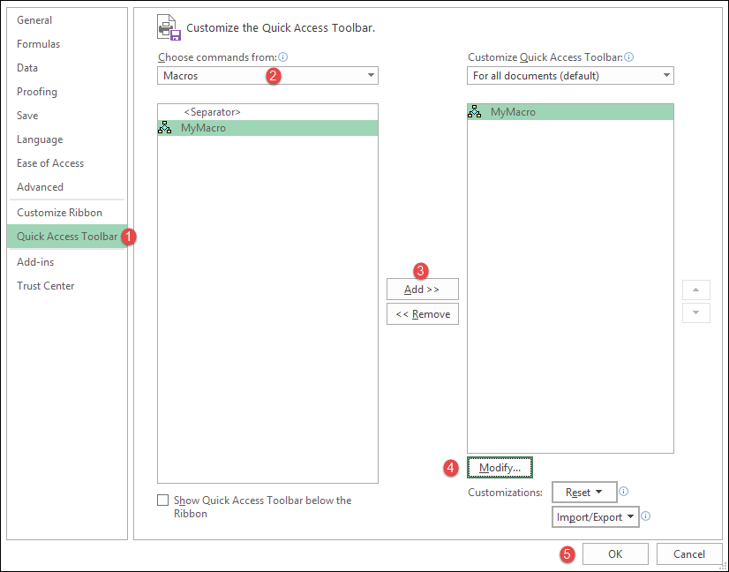
- After that, from “Choose Command from”, select Macros.
- Now select the macro (you want to add to QAT) and click on add.
- From here click on “Modify” and select an icon for the macro button.
- In the end, click OK.
Now you have a button on QAT which you can use to run the macro code you have just specified.

Time Saver Tips

1. Select Formula Cells
Let’s say you want to convert all the formulas into values and the cells where you have formulas are non-adjacent.
So instead of selecting each cell one by one, you can select all the cells where you have a formula. Here are the steps:
- First of all, go to Home Tab ➜ Editing ➜ Find & Select ➜ Go To Special.
- In “Go To Special” dialog box, select formulas and click OK.
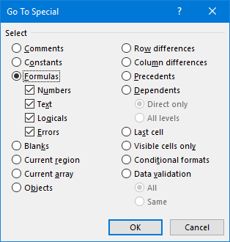

2. Multiply using Paste Special ★
To do some one-time calculations you can use paste special option and save yourself from writing formulas.
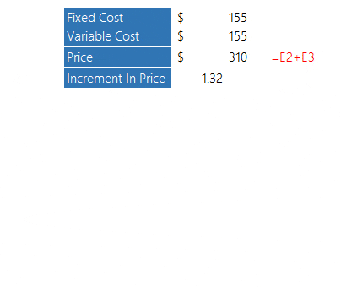

3. Highlight Duplicate Values
Well, you can use a VBA code to highlight values but the easiest way is to use conditional formatting. Here are the steps you need to follow:
- First of all, select the range of where you want to highlight the duplicate values.
- After that, go to Home Tab ➜ Styles ➜ Highlight Cells Rule ➜ Duplicate Values.
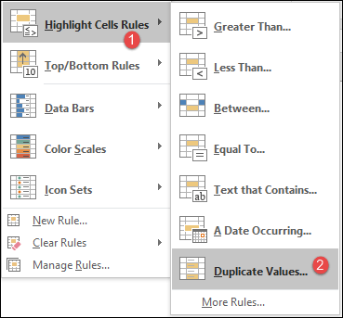
- Now from the dialog box, select the color to use and click OK.
Once you click OK, all the values which are duplicate will get highlighted.

4. Quick Analysis
If you ever noticed that when you select a range of cell in Excel, a small icon at the bottom of the selection appears. This icon called “Quick Analysis”.
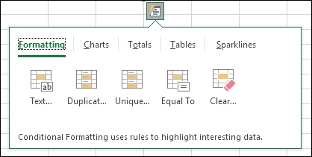
When you click on this icon you can see some of the options which are there on the ribbon which you can directly use from here to save you time.

5. RUN Command
Yes, you can also open your Excel application using RUN command.
- For this, all you have to do is open RUN (Window Key + R) and then type “excel” into it.
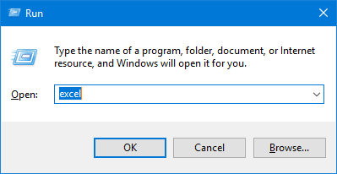
- In the end, hit enter.

6. Open Specific File
I’m sure like me you also have few or maybe one those kinds of workbooks which you open every day when you start working on Excel.
There is an option in Excel which you can use to open a specific file(s) every time when you start Excel in your system.
Here are the steps.
- Go to File ➜ Options ➜ Advanced ➜ General.
- In general, enter the location (yes, you have to type) of the folder where you have those file(s) in “At startup open all the files in”.
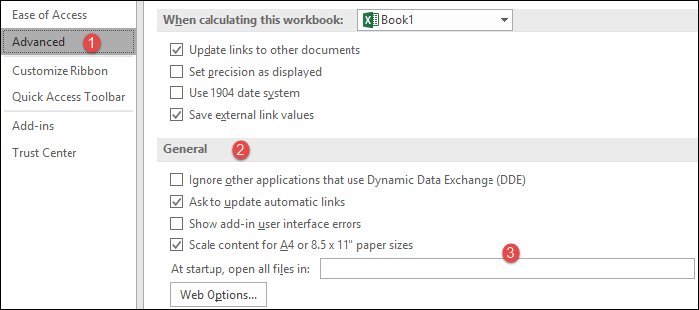

7. Open Excel Automatically ★
Whenever I “Turn ON” my laptop the first thing I do is to open Excel and I’m sure you do the same thing. Well, I’ve got a better idea here, you can add Excel to your system’s startup folder.
- First of all, open “File Explorer” by using Windows key + E.
- Now, enter the below address into the address bar to open the folder (change the username with your actual username).
C:UsersPuneet GogiaAppDataRoamingMicrosoftWindowsStart MenuProgramsStartup
- After that, open the Start Screen, right-click the Excel App, and click Open file location.
- From the location (Excel App Folder), copy the Excel App icon and paste it into the “StartUp” folder.
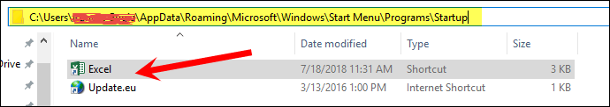
Now every time when you open your system, Excel will automatically start.

8. Smart Look Up
In Excel, there is an option called “Smart Lookup” and with this option, you can lookup for text on the internet. All you have to do is, select a cell or a text from a cell, and go to Review ➜ Insights ➜ Smart Lookup.
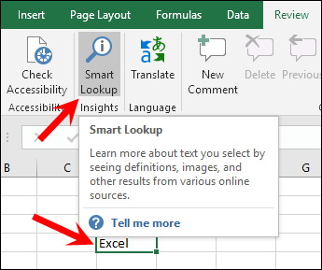
Once you click on it, it opens a side pane where you’ll have information about that particular text which you have selected. The idea behind this option is to get information by seeing definition, images for the topic (text) from different online sources.

9. Screen Clipping
Sometimes you need to add screenshots into your spreadsheet. And for this, Excel has an option which can capture screen instantly, and then you can paste it into the worksheet. For this go to ➜ Insert ➜ Illustrations ➜ Screen Clipping.
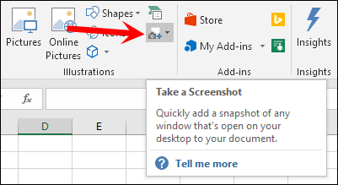

10. Locate a Keyboard Shortcut
If you use Excel 2007 to Excel 2016, then you can locate a keyboard shortcut by pressing ALT key. Once you press it, it shows the keys for the options which are there on the ribbon, just like below.
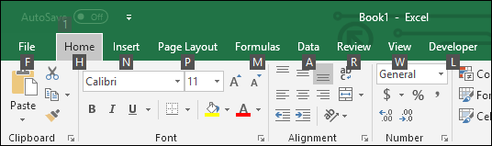
Let say, you want to press the “Wrap Text” button, the key will be ALT H W. In the same way you can reach to all the option using the shortcut keys.

Below are 10 of our favorite shortcuts, tips, tricks, and timesavers to supercharge your use of Microsoft Word. (Most of these suggestions work with all versions of Word, but some are exclusive to newer versions like Word 2013, 2016, or 2016 for Mac.) Try a few out today and let us know what works for you…

1. Copy, paste, and cut with keyboard shortcuts.
Ask anyone who knows these shortcuts — Ctrl + C to copy, Ctrl + V to paste, and Ctrl + X to cut — and they will testify to their critical timesaving nature. Master these three basic commands first and you’ll find yourself zooming through document creation at surprising speeds.

2. Quickly zoom in or out to save eye strain.
Some people like to work in a Word window zoomed in to 150%, while others like to eliminate the need to scroll left and right or up and down by zooming out to 75% to see a document in its entirety. Either way, use the Window > Zoom button to choose the setting that works best for you — or look for the “100%” tab with a slider at bottom right of the document to easily zoom in or out.

3. Delete entire words at a time.
This is an easy one you may not know about: instead of slowly pecking at the keyboard to delete text, or holding down Backspace to eliminate words or entire sentences, press Ctrl+Backspace with the cursor placed after a word you want to erase a word at a time, making a tedious task much easier.

4. Use Smart Lookup to search the Internet.
Anytime you highlight a word or phrase and right-click it, you’ll see “Smart Lookup,” which serves as a quick shortcut to browse the web — without slowing down to open a separate browser window. From word definitions to news scans, this powerful tool can transform a simple question into a wealth of knowledge.

5. Remove unwanted formatting.
Trying to turn a document from an external source into something that works for you? Strange formatting can slow you down, so instead of trying to fix one thing at a time, press Ctrl + Space or click the Clear All Formatting button (in newer versions, an eraser on an A on the Home tab) to remove formatting from highlighted text and start fresh with your own style.

6. Tell the program exactly what you want to do.
Most newer versions of Word include a handy “Tell me what you want to do” field at the top of the toolbar. Insert a word or phrase pertaining to any instruction and the program can quickly identify the command you’re looking for.

7. Use multiple clicks to select chunks of copy.
Rather than employing the tedious drag and highlight method, you can use your mouse to select chunks of copy: double-click over a word to highlight it or triple-click to highlight an entire sentence or section.

8. Quickly insert links into a document.
Similar to the copy / paste / cut commands, learning the keyboard shortcut for adding web links to a document — Ctrl + K — will save lots of time and quickly become one of the sharpest tools in your kit.

9. Select the default font you want, not the default font Word wants you to use.
Don’t like Calibri or Cambria? Prefer Arial to Times New Roman, or like the modern nature of Verdana? The best part about Microsoft Word is you can choose the default font — this command differs by version, but the most reliable way is to click Format > Font, select the attributes you want, and then click Default.

10. Find any word you want quickly and easily.
Instead of using your mouse to navigate to the Find command, click Ctrl + F to either open the window in older versions of Word, or move the cursor automatically to the Search in Document menu that always appears in the toolbar in newer versions.
BONUS TIP: Click the drop-down arrow on the Find menu’s magnifying glass and click Replace to automatically replace a certain word or phrase with a different word or phrase you specify.
No matter what your level of proficiency with Microsoft Word, we could all use a boost to make our use of the program more productive and efficient. Curious about how the Office productivity suite can have an impact on your day-to-day operations? Wondering about whether it’s time to upgrade your version of Word? Have other tips and tricks that have revolutionized your use of the program? Contact CMIT Solutions today.
power point presentation tips and tricks:
1. Morph transition take a slide and duplicate it and choose second slide and choose the morph option which is present transitions and move items around the screen and click on morph option:.
2. compress media:choose insert option and select vedio option and vedion my pc choose a file and inserts into power point to compress the media go to file and select compress media option and click on undo.
3.ctrl+drag to duplicate:one of the fastest way to duplicate the object.select an object ctrl+drag to duplicate.
4.Ink Equation:goto insert select symbols select equation and choose ink equation here we can write math equation by hand choose write .
5.Alt-shift ordering:if we want to reorder the items in bulleted list the short cut is to highlight what you want to move ,hold the shift+alt keys and hit up or down arrows to move it up or down.
6.Ungrouped smart art:it’s a great tool to insert graphics in to your power point presentation
select insert click on smart art select any art right click on thae art(block) choose group choose ungroup and do it second time we can un group a component as separate items .
7.quick access toolbar:it is situated at the upper left corner of the all office products .click the down arrow click more commands go to commands not in ribbion select quick print select add select second one speech bubble and select toggle full screen option and select add option quick print option and select speak selected text allows computer to read back your text .If we highlight something abd click on speak selected option it plays it for u.

8.quick print is handy bcse we can click ths button to automatically print directly to your default printer without having
9.Toggle case option allows u to toggle case If we highlight something and select toggle case option it switches to sentence case mode
10.filler text:click insert select text box and insert box any where and type directly into the box “=lorem” and hit enter that prints latin text the you can resize as necessary and we can also type “=rand()” instead of lorem we get
both of these options allow parenthesis that is the no of paragraphs and the no of sentences within each paragraph so that we can adjust it accordingly.
ex:=lorem(2,4)
11.chart Animations:click on the chart choose animations tab and click on the animation pane and choose animation for the chart like “float in” click on effect options and choose by series or by category option
12.slide show tricks:hit the “f1” key.hit the “w” key to while out your screen hit it again to bring it back .u can also hit “b” to blank the screen out so that you have nothing on the display and hit “esc” to come back.If u hit “ctrl+p” it brings up a pointer and you can use this to mark things on your chart while you are talking.if you hit ”e” it will erase and start over .ctrl+I brings up a highlighter so that you can highlite items on your chart and again “E” to erase .hit “+” to zoom in and “-“ to zoom out all of these are available by hitting “f1”.
13.Gridlines and guides:select view tab and click guides it brings up the hoeizontal and vertical lines in the center of the screen when you hover over that u Can actually move these lines where u want to position alignment and u can take abject and u can position that object into that position u can also turn on grid lines and see the background gridlines to help u align the other things around the page or u can align the guidelines to ur object if u hit the arrow key in corner here u can choose snap objects to grid option and u can also adjust the spacing if u click set as default it will store that settings for other presentations and pages u can select ruler option which shows the no of inches vertically and horizontally across your page if you need to do things by measurement.
14.recover files:if u have been kicked out of power point or u forgot to save a file,not to worry there is one possible chance that you can recover it go to file open and at bottom of the list u can see the unsaved presentations option click that it opens in that location if there is any file u can opeh it and save it.
15.eye dropper:the easiest way to match the color of text with some other object is to higllight that text click on the color option and select eye dropper and select any color from any place on the screen.
16.shape edit tools:it’s a power ful tool that allows any kind of combination of shape you can think of.
Start by inserting a shape by selecting insert and select shapes option on your campu and click the edit shape edit points option this vreates an ability to take corners of ythe drawing and shift them around.
right click on the edge and select the curve segment which adds a curve to that edge.
17.smart look up animations:select any part of the sentence select review and click smart lookup it goes to the web looks up the topic and gives you some information
18.slide show loop:click on slide show and click set up slide show and check loop continuously until esc.
Windows XP TRIPS AND TRICKS
Changing Start Button Text: type download.com in chrome hit enter and type resource hacker hit enter select resource hacker 3.4 option and hit download now option. select open option select ResHacker option click extract all option click next ,next and hit finish option click ResHacker option and click run. click on file and open select c drive as location and select windows option and select explorer option select string table option
Open 37
ADD A WEEK IN A DATE
Input: Friday, 01-Jan-21
Add three weeks to the current date
=SUM(Cell no,no of days to add)
Eg: =SUM(A1,7*3) and hit enter
Output: Friday, 22-Jan-21
Get month name from a date
Input: 1-Jan-22
=TEXT(Cell no, format_text)
Eg: =TEXT(A1,”mmm”) and hit enter
Output: Jan
To get full name of the month use
=TEXT(A1,”mmmm”) and hit enter
Output: January
Kill “specify the path of the folder”
Eg: Kill “C:\Users\puneet\Desktop\data\*.xl*”
It will delete all the folder content
Create a Input Box
(Using Microsoft Visual Basic for Applications)
Sub vba_input_box()
InputBox(Prompt,[Title],[Default],[XPos],[YPos],[HelpFile],[Context]) As String
End Sub
The important parameters in the input box are prompt, title, default
Eg: Sub vba_input_box()
InputBox(“Enter your first name here.” “Enter Name”, “For Example: John”)
End Sub
Now to get the value from the input box in a specific cell
Sub vba_input_box()
Range(“B1”)=
InputBox(“Enter your first name here.” “Enter Name”, “For Example: John”)
End Sub
Sub current_date_time()
End Sub
Input: 11-Dec-2021 11:30 AM
INT(cell no)
11-Dec-21

10 Excel Keyboard Shortcuts (Probably YOU are NOT Using)

Press ctrl,t for popping up the create table dialog box and tick mark (my table has headers) and click on “ok”
Press the shortcut key alt,d,o and it will open the user form that’s used to enter the data
Inserting a chart
Select the data on excel sheet and press the keys alt,f1
It will instantly insert the column chart
If you want to insert the line chart then go to insert option and go to all charts option and select any line chart right click on it and select the set as default chart and press the alt,f1
Click alt,= and select the columns so that it will add the values and gives total of values for columns and rows
Spell check
If you work with textual data in work sheet u can use f7 to perform spell check and by clicking change, change all
Selection Mode
When you have to select multiple cells that are non continuous we need to press the ctrl and select each cell one by one
Shift,f8 and it will activate add or remove section no need to select ctrl key but we can select multiple cells by simply using your cursor and if you want to deselect click on the selected cells
Rename a sheet
Select alt,h,o,r
To delete a work sheet
Select alt,h,d,s
Auto Format
It helps to quickly applying formatting to the data in the work sheet,
click Alt,o,a it will show the dialog box and choose the formatting that you want to apply, and click ok
Time stamp
Ctrl,; to insert the current date(date is a hard value It cannot be changed), to inserrt current time press ctrl,shift,;
Flash Fill
For getting the first name of a cell the short cut key used is ctrl,e
Input: mira radia
Output: mira
Full screen view of the excel sheet
Atl,v,u
To exit the full screen press esc

Create a Named Range using VBA | Excel VBA
In excel go to the developer tab and click on the visual basic to open the visual basic editor
Click on insert and go to the module to inseert a new module
Type:
Sub vba_named_range()
ActiveWorkBook.Names.Add “myRange”, “=Sheet2!$A$1:$A$5
End Sub
Here $ sig is used to freeze the range
Sub vba_named_range()
ActiveWorkBook.Names.Add Name:=”myRangeName”, RefersTo:=Selection
End Sub
To dynamically select the range of the cells

Run Macro When You Open/Close a Workbook (Excel File) - Excel VBA
Sub mymacro()
MsgBox “Hello!”
End Sub
Sub auto_open()
MsgBox “Hello!”
End Sub
Sub auto_close()
MsgBox “Hello!”
End Sub
=POWER(A1,1/3) and hit enter
=A1^(1/3) and hit enter

VLOOKUP in VBA
Sub vba_vlookup()
Range(“F3”)=WorksheetFunction.VLookup(Range(“E3”),Range(“A:B”),2,False)
End Sub
VLookup is used to look up value to be searched

Count Blank Cells | Excel Formula

=COUNTBLANK(A1:A10)
=COUNTBLANK(RANGE)
=COUNTIF(A1:A10,”=”)

SUM Less Than Values (SUMIF)
=SUMIF(A2:A13,”<25”)
=SUMIF(A2:A13,”<=”&B2)

Count Unique Values
=COUNTA(UNIQUE(A2:A15,FALSE,FALSE))

Generate Random Letters
=CHAR(RANDBETWEEN(65,90))

Military Time Format
=TEXT(A1,”HHMM”)

How to Create a PICTOGRAPH in Excel
Pictograph is not a seperate or different kind of a chart but converting a bar from a bar chart with icon where you can insert an icon or you can also use the stock icons from the excel
Steps:
- Create a table of data set
- Go to insert tab and go to the bar chart logo and select a bar chart
- Right click on the bar and select format data series in this go to fill and line option and select picture or texture fill option and select insert in the insert picture from source
- To change th ebackgrpund of the bar chart select the format option, select shape fill option

Square Root
=SQRT(A1)

Remove Unwanted Spaces / Quick Formula
=TRIM(A1)
=SUBSTITUTE(A1,” “,””)
=CLEAN(A1)

Get Day Name / Quick Formula
=TEXT(A1,”ddd”)
=TEXT(A1,”dddd”)

Get Day Number / Quick Formula
=DAY(A1)
=WEEKDAY(A1,2)

IF Negative Then Zero
=IF(A1<0,0,A1)

Get Quarter from a Date / Quick Formula
=CHOOSE(MONTH(A1),1,1,1,2,2,2,3,3,3,4,4,4)
=”Q-”&CHOOSE(MONTH(A1),1,1,1,2,2,2,3,3,3,4,4,4)
=CHOOSE(MONTH(A1),Q for month jan,………,Q for month dec)
- Quarter

Add Leading Zeros / Quick Formula
=TEXT(A1,”000000”)

Round to Nearest 1000 - 100 - 10 / Quick Formula
=ROUND(A1,-3)
INPUT: 123456789
OUTPUT:123457000

3D Range / Quick Formula
=SUM(Sheet1:Sheet5!A1)
=SUM(Sheet1:Sheet5!A1:A5)
(For Range of sheets)
Add Minutes to Time

Combine Data from Multiple Files using Power Query (Merge Files in Excel)

Here the worksheet name and the table name are same for all files
Go to data tab and in get data ans transform data click on get data and click from file and then click folder and select the folder from where I want to combine data and click open here it shows the list of files present from here I click on combine in the dropdown select combine and transform data option and the next pop up appears and in that in the parameter1 we have two options one is table name and second is the worksheet name click on worksheetname and click ok
Some changes to be made in the final combined file
- changing the 1st column name, and remove the .xlsx for this go to transform and click on replace values in the value to find type .xlsx and in the replace with leave it blank and click ok, remove the serial no column for that right click on it and click remove
- Power query is real time so when you do something in power query it store those steps and you don’t need to that action again and again you just need to refresh it and it will get updated data for you from the source files
- Here the data is ready and go to the home tab and click on close & load
- So next is to update the value in a column in a table for that go to the original 1st file and update a value in a particular column and do it for two or more columns for that particular row save that file and close it. Right click and click on refresh in the final combined file

